Summary of the Overdose Evidence Update and Strategic Program Review
Executive oFfice of Health and Human Services (EOHHS)
Report to the State of Rhdoe Isalnd Governor’s Overdose Task Force
2021
Contents
Executive Summary: 1
Introduction & Background: 3
Qualitative Analysis: 4
What We Learned from the Qualitative Interviews: 4
Quantitative Approach: 6
Quantitative Analysis Results: Dec 2018 - June 2019 vs. Dec 2019 – June 2020 7
Differences in Other Key Factors and Subgroups 9
Those with Fentanyl and / or Methadone Listed as a Cause of Death 10
Other Key Analyses To Inform Quantitative Review 17
Qualitative + Quantitative: Combined Study Results 21
Current Activities: 23
Context of the Report Recommendations 23
Suggested Priority Recommendations: 25
Governor’s Overdose Task Force Implementation Planning 27
Recommendation Implementation 28
Priority Recommendation Implementation 30
Next Steps: 33
Acknowledgements 33
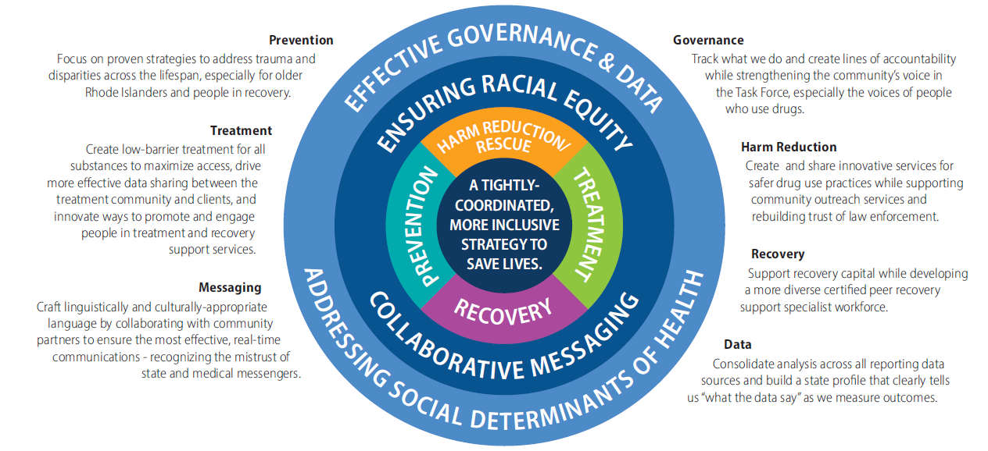

Evidence Update & Strategic Program Review Report | February 2021

Executive Summary:

Starting in November 2019, the Co-Chairs and other members of the Governor’s Overdose Task Force recognized that accidental fatal drug overdoses were rising. During the fall of 2020, the Task Force Co-Chairs asked the Executive Office of Health and Human Services (EOHHS) to examine the rising numbers with an Evidence Update and Strategic Program Review.

The overarching research team carried out a mixed method review with quantitative and qualitative components. The data team analyzed demographic, medical, and economic differences in two groups of people – a 2020 cohort, who died between Dec. 2019 and June 2020 and a 2019 cohort, who died between Dec. 2018 and June 2019. The research team also held 44 Focus Groups or Key Informant Interviews with over 100 experts in Rhode Island: people who use drugs and family members of people using drugs or who overdosed, plus leaders of community-based organizations and state agencies, and healthcare providers and academic researchers.

The combined qualitative and quantitative Evidence Update and Strategic Program Review (SPR) uncover the centrality of three drivers of fatal overdoses – and a key response challenge:
- The sustained presence of fentanyl and analogues in the drug supply, including nearly 75% of all overdose deaths in 2020. Fentanyl is now present in many types of drugs (not limited to opioids), and potentially growing in potency.
- COVID-driven social isolation, fear of disease to the point of not calling paramedics for help, and economic insecurity – all of which may exacerbate, or be exacerbated by, underlying anxiety and depression, which were significantly more common in our 2020 cohort.
  - The 2020 group showed more evidence of being in a fragile state of recovery before death and were more likely to die at home before rescue arrived.
  - Middle age men – those 40-59, especially those with underlying mental health conditions – were especially hard hit in 2020.
- These factors are more acute for communities of color, for whom historical inequities and ongoing structural racism have deprived them of equitable capital (recovery, financial, social), trust in institutions, and access to equitable services.
Further, an insufficient governance and project management structure underlines the state’s difficulty in pivoting quickly enough to assess and respond to the changing drivers of the crisis. It also limits our ability to guide a consistent, focused, strategic response that weaves emerging information into action.
A companion analysis by Brown University analyzed two additional months of death data (July and August 2020), which were finalized in late December 2020.

The core recommendation from the SPR is that Rhode Island must accelerate a tightly coordinated, more inclusive strategy centered on harm reduction and recovery resiliency for people at high risk of fatal overdose right now to save lives.

We chose these words very carefully:
- Tightly coordinated means better governance – better project management that holds people accountable to doing what’s assigned to them – and shares the outcomes transparently

- More inclusive means including a more diverse group of people in the work, racially and ethnically, gender, sexual orientation and gender identity, and age – and with a race equity lens to all activities

- Centering on the key things we learned harm reduction and recovery resilience means prioritizing those activities to save lives.
To accomplish these updated strategies, the report lays out a set of 14 prioritized recommendations, 12 short-term recommendations that are either in process already or that stakeholders thought could or should be implemented more quickly, and then a more complete set of long-term recommendations that complete the proposal.

Together, these will help the Governor’s Overdose Task Force move forward to an overall more organized and effective response to addiction and overdose.

Besides the recommendations, this report includes:

- The data and information stemming from the analysis, plus the updated companion analysis

- A discussion of the key drivers of the overdose deaths – fentanyl, COVID, structural racism, plus the governance challenges of dealing with the overdose epidemic

- A review of current activities taking place to address the rising number of overdose deaths, including work in the months immediately following the evidence update (through Feb. 2021)

Introduction & Background:

Rhode Island is on track to exceed 400 overdose fatalities in 2020, despite years of steady progress, and heroic efforts to continue treatment, outreach, and recovery services as much as possible during COVID. Most performance metrics are strong and stable across all pillars, yet more people are dying than ever before.

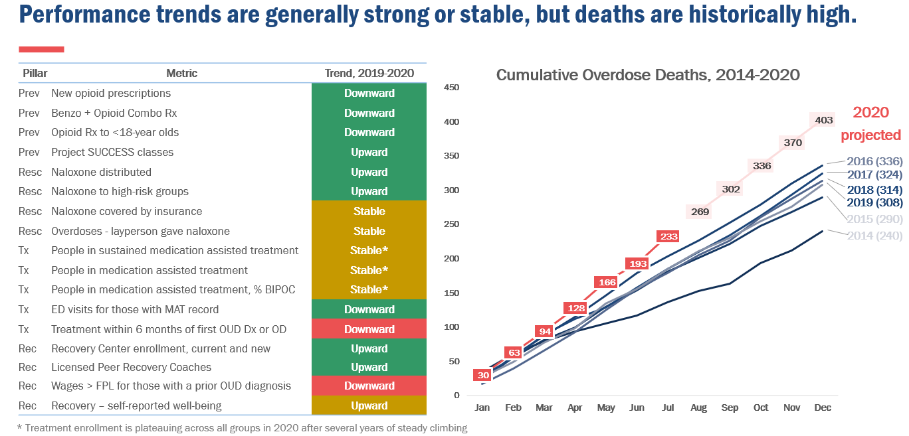

The Co-Chairs of the Governor’s Overdose Task Force asked Rhode Island’s Executive Office of Health and Human Services (EOHHS) to study the situation and help determine:

- What changed?
- How do we know?
- How do we respond?
- How do we ensure that this does not happen again?

Study Format: EOHHS carried out a mixed method research project, with both quantitative and qualitative research components. In both approaches, we sought to understand changes that were occurring before and after the inflection point in year over year increases in overdose related deaths in Rhode Island – around December 2019 – and before and after the social and economic effects of the COVID pandemic hit – around March 2020.

Qualitative Analysis:

The Evidence Update + Strategic Program Review Team carried out qualitative research – focus groups or key informant interviews with over 100 people in 44 Key Informant Interviews or Focus Groups. The participants interviewed included:

- People who use drugs and family members of people who use or used drugs
- Every state agency involved in opioid response
- SUD community providers, including large and small agencies and PCPs who provide services
- Hospital staff
- Community organizations, with a focus on harm reduction orgs
- Law enforcement representatives
- Academic and programmatic experts

This was a chance to take another look at the data and dig deep in a set of interviews – to be humble and determine what has changed. How do we know? What might we – as a community – not be doing right? And what can we do differently?

The main questions the team asked participants were the following:

- What are the positive things Rhode Island’s system is accomplishing?
- What changed over the past two years?
  - Between January 2019 and February 2020, when deaths were first rising, and
  - From March 2020 on, because of COVID?
- What impact did structural racism and the focus on race equity that rose up over the summer have on the changes?
- What insights could we gain about how the actions of the organizations and individuals involved in the Task Force (state leadership and staff, the provider community, community organizations, and families and people who use drugs) were misaligned, or where there was overlap or duplication in activities?
- If the interviewee had a magic wand and could change anything about our response to the addiction and overdose epidemic, what would they do?

As the research team noted in each of our Focus Groups, the Task Force and its participants all know too well about the pain of all of the overdose deaths since the beginning of the Task Force – a high of 336 in 2016, then decreasing – until this year. Rhode Island may exceed 400 overdose deaths despite amazing efforts to continue on with services during COVID, and stable and strong performance metrics across all pillars. These deaths are not just numbers – they're our neighbors, friends, family members – our loved ones.

What We Learned from the Qualitative Interviews:

In over 50 hours of interviews, participants shared input on what was going well, what had changed before and during COVID, what wasn’t going well, and what the state should do differently to save lives. The response fell in six areas, described below:

Harm Reduction: Partners noted that no matter what we do, there will still be people in Rhode Island who use drugs. Deadly fentanyl, COVID isolation and anxiety, and racial disparities make the risk of using drugs more dangerous than ever. In particular, the existence of fentanyl in so much of Rhode Island’s drug supply, in drugs beyond just opioids, means that people will encounter it more and more, deliberately or not. Participants underlined that ignoring this reality is wrong – and attempts to ban behavior only drives it underground. Therefore, a clear takeaway from the qualitative study was the need to focus intently on harm reduction as a life-saving strategy. This focus includes provision of resources, policy changes, institution of new programs, and direct and specific messaging - as well as understanding and grappling with the challenging connection between opioid use and the criminal justice system.

Recovery: Peer Recovery specialists are a critical part of the recovery story – and we must ensure that we recruit and retain more specialists of color. But focus group participants returned over and over to the need to strengthen recovery capital, by addressing social determinants of health – the lack of housing especially, and stable employment that is conducive to recovery lessons. The research team also heard about problems with the ways that we currently measure recovery. Recovery cannot only be about the number of people participating in MAT – the state should also measure smaller recovery accomplishments. Finally, participants identified the lack of face-to-face engagement during COVID as a significant problem contributing to people’s challenges staying in recovery.

Governance: Rhode Island has a broad and diverse group of individuals and organizations participating in the Overdose Task Force and focused on supporting and saving lives of Rhode Islanders who use drugs. Throughout the interview, though, the research team heard about gaps in coordination between and among the various Task Force participants and a lack of project management that makes it more difficult for the state to reach our goals. Participants also focused on the need to include a more diverse set of community voices in decision-making.

Treatment: Participants noted that the state does a lot right here, with Medication Assisted Treatment (MAT), especially for people with insurance and for people in the Adult Correction Institute. But for people without insurance – people who are undocumented, for instance – and for people who find it more difficult to negotiate the healthcare system, it is much more difficult to secure ongoing treatment, and participants talked about how it got even harder during COVID. In particular, the research team heard that we need to focus in on improving the quality of treatment across the board through investments in providers, increase cultural competence in our treatment providers, and address the challenges of insurance companies’ requirements for ongoing authorizations for treatment.

Prevention: The message we heard here was clear: look farther upstream to prevent addiction. Participants urged the state to return to addressing the social determinants of health, because true prevention comes from ensuring safety and security through housing and jobs, preventing violence and trauma, and addressing disparities and discrimination. The team clearly heard that prevention needs to be across the lifespan – not just youth.

Messaging: Here, the research team heard about challenges in our content, messages, and our messengers. Participants were clear that the state is not a trusted messenger about issues related to drug use. The state must do better to engage the community – including people who use drugs or who are in short-term recovery – to improve how we’re reaching out in culturally competent ways.

Quantitative Approach:

To best see the trends that may have contributed to rising overdoses in 2020, but may have preceded COVID, we looked closely at deaths from overdoses of any drug – not just opioids - that occurred from December 2019 – June 2020, the most recent month of finalized data at the time our study began. A companion study from Brown University added July and August to the study and is discussed in later pages.

We also looked at broader trends in addiction, treatment, incarceration, police activity, and drug seizures during that time. Notably, this period begins in the first month we observe year of year increases and fully includes the early stages of COVID spread, awareness, mitigation, and isolation.

We compared this group to those who died in the same months the year prior, resulting in two cohorts:
- 2020: Those who died between December 2019 and June 2020 (223 people)
- 2019: Those who died between December 2018 and June 2019 (181 people)

The Department of Health (RIDOH) provided a list of individuals who died of a confirmed overdose during these periods, along with their month of death. The EOHHS analytic team matched other records using the existing Data Ecosystem integrated data platform to pain a more complete picture of each person prior to death. Data sets included:

- Death certificate data from Vital Records, including demographics known at the time of death, cause(s) of death, toxicology information, residence, and location of death

- Earnings and Income Support from Department of Labor and Training (DLT) quarterly earned wage and employment records; and claims for unemployment insurance (UI), Pandemic Unemployment Assistance (PUA), and Temporary Disability Insurance (TDI)

- Medicaid medical claims and eligibility for approximately 60% of individuals who had a Medicaid record at some point between July 2013 and June 2020: Medicaid eligibility and claims, including opioid agonist therapy (methadone and buprenorphine), non-fatal overdose, mental health diagnoses, and treatment
  - Medicaid eligibility also provides an imperfect but useful proxy for department of corrections stays and lengths of stay. When someone is on Medicaid and moves to DOC, their Medicaid is suspended during incarceration and indicated as such in their eligibility records.

The team also reviewed data sets related to broader environmental factors, including:
- Incarceration census, intake, and release trends from January 2018 to Sept. 2020 split by:
  - Offense type
  - Security level
  - Gender
  - Sentenced status

- Drug supply information
  - New England High Intensity Drug Trafficking Area (HIDTA) reports on drugs seized
  - Rhode Island State Health Lab (RISHL) Toxicology reports on drugs seized

- Overdoses and treatment patterns for those who received treatment at Roger Williams Medical Center prior to its closure in May 2019.

Quantitative Analysis Results: Dec 2018 - June 2019 vs. Dec 2019 – June 2020
Population | 2019 | 2020
Full Population | 181 | 223
Also in Medicaid | 108 | 129
Medicaid % of Total | 60% | 58%
There were 24% more overdose deaths (n = 223) in the 2020 cohort than the 2019 cohort (n = 181), though the two cohorts were demographically similar and had about the same rate of enrollment in Medicaid at any point between July 2013 and their date of death.
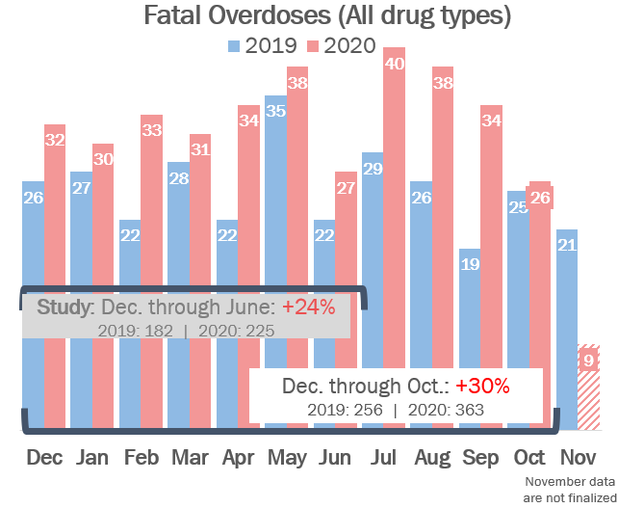
Figure 1
Figure 1 shows fatal overdoses by month from December of 2018 through the preliminary Nov. 2020 data. These are the most recently available data and are being finalized by the state’s Medical Examiner. At the time of the study, data through June were finalized (grey text box). Figure 1 also includes the months of data that are now finalized as of this writing (February 2021) – July, August, September, and October 2020.
Note that the year over year growth, by month, starts in December 2019 and continues through at least October.
Table 1 highlights that few demographic fields are statistically significantly different. The largest differences, as a percent of the total cohorts in each year, are Hispanic ethnicity (+4.5 percentage points), Ages 50-59 (+2.3%) and African American race, Ages 40-49 (-2.0, each).
Table 1: Summary of Key Demographic Features

Differences in Other Key Factors and Subgroups
There were, however, more significant and telling differences when we examined key factors at the whole group level and in select subgroups – specifically, those who had fentanyl and/or methadone listed as a cause of death, those in their 50s, and those who died at home (rescue services were either not called or arrived too late for transport). We detail the significance of each of these areas below.
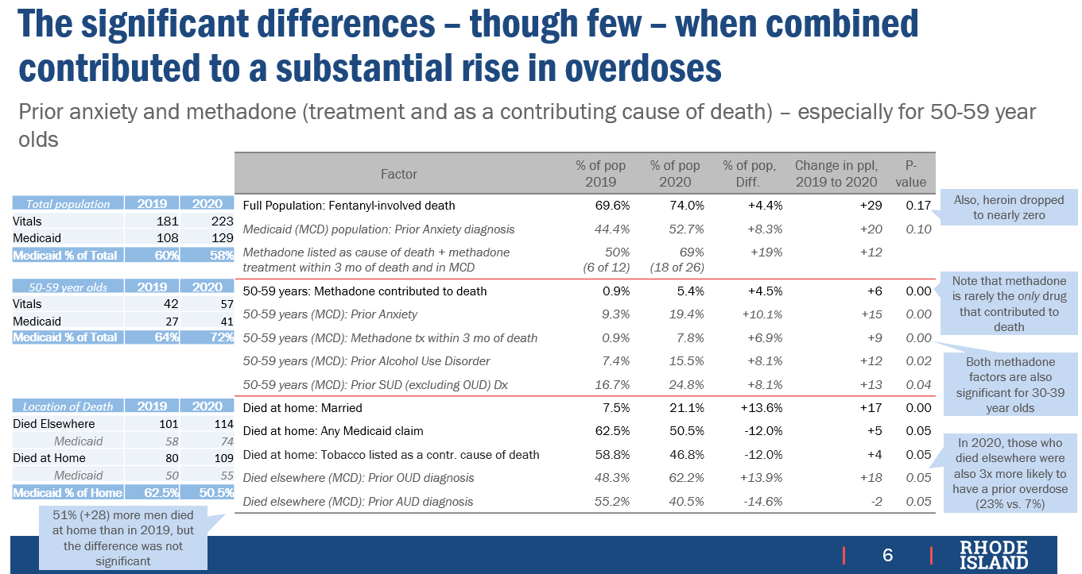
We highlight these three groups because, of the hundreds of factors we reviewed, these groups showed the most statistically significant differences, year over year – and in fact, were the few that showed any statistical significance.
Figure 2: Key differences among subgroups

Though the differences are small, marginal changes layered together drive substantial growth in fatalities. Indeed, from these data emerge a pattern that more closely describes the 2020 group than the 2019 cohort:
- A population who may be in recovery (methadone in their system at the time of death and recently in treatment),
- Those whose recovery may be fragile (evidence of prior anxiety or depression symptoms), and
- Those who were either using alone or with people who did not (could not or would not) call for rescue services with enough time to prevent the death.

Those in their fifties were more likely to have prior mental health diagnoses, have methadone at the time of death, or to have recently been in treatment

Those with Fentanyl and / or Methadone Listed as a Cause of Death
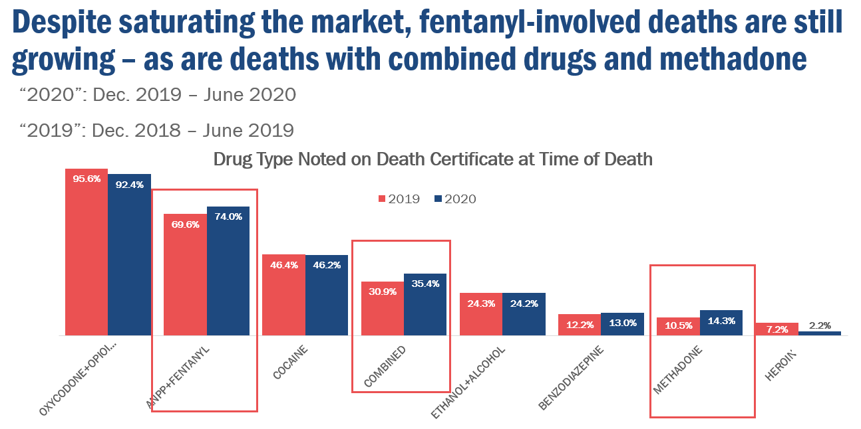
Figure 3: Toxicology results of fatal overdoses, by cohort
Figure 2: Key differences among subgroups
Fentanyl | 74% of overdoses in the 2020 cohort involved fentanyl or an analogue, up from 69% in the 2019 group. While this jump was not technically statistically significant (p = 0.17), it underscores that the drug supply is approaching fentanyl saturation. A nearly 5 percentage point increase, year over year, on an already large base is a frightening trend on its own, and over a slightly longer period with more growth, would likely have been statistically significant.
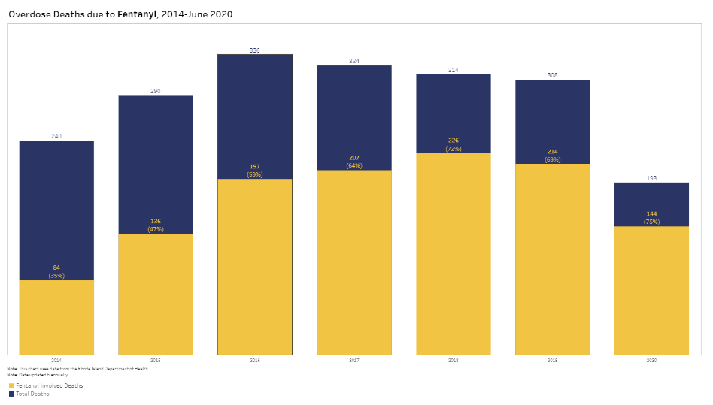
Fentanyl is a synthetic opioid that is used to treat pain but is 50-100 times more potent than morphine (National Institute of Health, 2020). Fentanyl and its analogues have been poisoning the drug supply for years, but grow substantially between 2014 and 2018. After a slightly lower year in 2019, we see the trend rising again to 75% of all calendar year 2020 fatal overdoses.
Figure 4: Overdose deaths related to fentanyl, 2014-2020
The qualitative aspects of the evidence update, detailed in further sections below, provide context for why the supply is poisoned, including what incentives dealers have to taint drugs – opioids and non-opioids - with such a lethal substance. From a quantitative perspective, however, we note its substantial and rising presence among all fatal overdoses, the near absence of heroin, and the growth of “combined” drugs contributing to death.

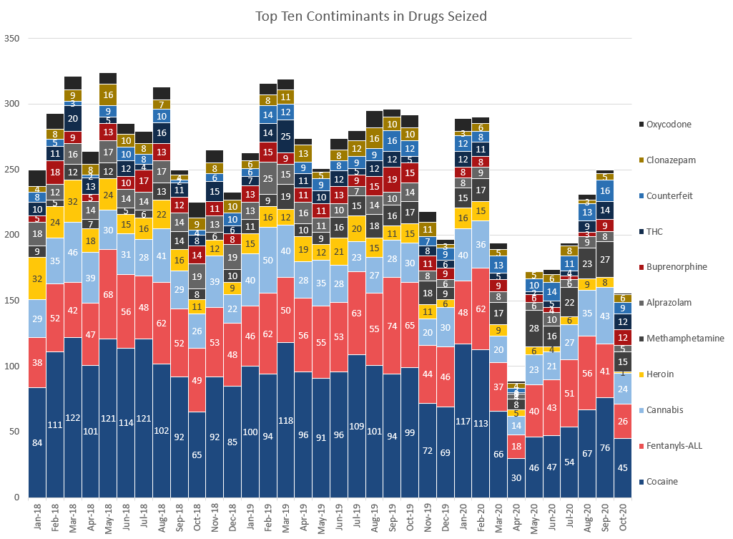
Drug Supply: Toxicology of drugs seized
Figure 5: Contaminants in Drugs Seized by Municipal Police Departments, as reported by the Rhode Island State Health Lab
It is important to note, however, that while fatal overdoses increasingly involve fentanyl and the drug supply is substantially tainted with fentanyl, analysis of drugs seized did not show a fentanyl increase in 2020 – in fact, we see a decline, due to fewer drug seizures during the early COVID quarantine period. These reduced drug seizures result from more people at home – so less public activity and crime - and less proactive policing for fear of unnecessarily spreading the virus.

Methadone as a Cause of Death and Those in Recent Treatment
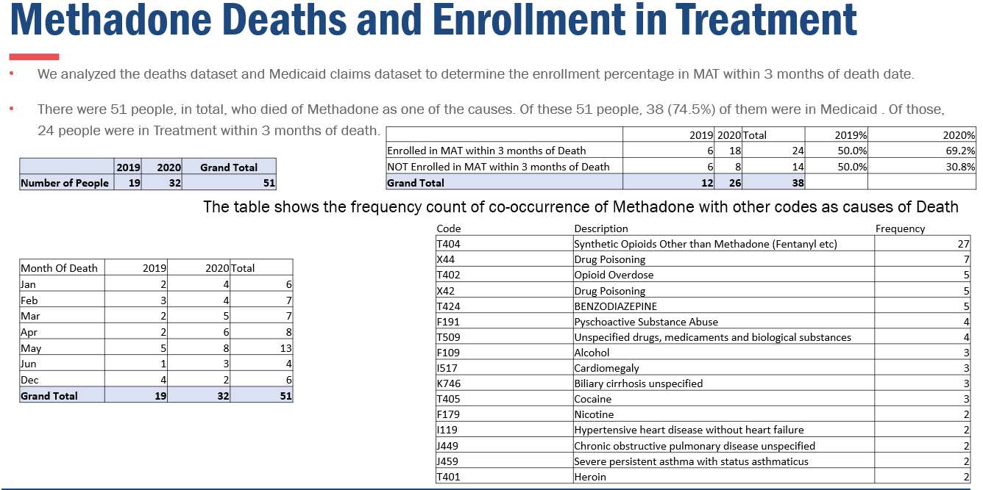
The 2020 cohort also saw a rise in the number of people (+12) and percent of total (+19 percentage points) people who had methadone listed as a cause of death who had a record of recent methadone treatment. The data show that 51 people – 19 in 2019 and 32 in 2020 – had methadone listed as a cause of death. Of these 51, 38 had a record in Medicaid, which would allow us to see if they were recently in Medicaid-funded methadone treatment. Of these 38, 6 of 12 (50%) in 2019 and 18 of 26 (69%) in 2020 had a methadone treatment record within three months of their death.
Figure 6: Methadone as a cause of death: Key statistics from death certificate data
Take-home Methadone | Notably, during this period, Rhode Island’s opioid treatment programs, following updated emergency regulations from the federal government, greatly expanded take-home methadone services beginning in Mach 2020. Take-home methadone was previously permissible for those who had evidence of stable long-term recovery and successful daily in-person medication pickup. But reduced in-person access during the early COVID period pushed the government to expand approved take home use for many more people including those recently entering recovery. The take-home program was a life-saving innovation and ensured that people who rely on opioid agonist therapy (OAT), such as methadone, received consistent access to these critical drugs. And, as with any sudden, massive change in how a program operates, we may find opportunities for improvement to ensure these powerful changes stick in as sustainable a way possible.
Methadone as a “Cause of Death” | Though methadone was listed as a primary cause of death (“Cause Line A” on the death certificate), it was rarely, if ever, listed as the single cause of death. It was almost always listed with another drug that contributed to death. However, the growth in the population who had recently been in treatment and died with methadone in their system, listed as a primary cause of death, is notable. It tells us that the 2020 cohort was more likely to have people who were in opioid agonist therapy (OAT), such as methadone, and who may have returned to use due to the isolating and anxiety-triggering effects of the pandemic. They may have also had reduced tolerance or not expected fentanyl to be as present or as potent in the drug supply and then suffered a fatal overdose.
The data tell us that the transition into and out of supported recovery services, such as OAT – are critical periods. Interventions that stabilize and strengthen the recovery period – increasing recovery capital and resiliency – or actively support recovery in whatever form possible may be among our most powerful options for reducing fatalities. We detail policy and program options in the coming pages, as well as qualitative findings to give context to these quantitative themes.

Those with Prior Anxiety Diagnooses, and Those between ages 50-59
From the second row in Figure 2, we see that in 2020, nearly 53% of the population with a Medicaid record – about 60% of those who experienced a fatal overdose – had a prior diagnosis of anxiety. That figure represents an 8.3 percentage point increase over 2019, and 20 more people total.
Figure 2: Key differences among subgroups
Though, like the growth in fentanyl-related overdose death, prior anxiety diagnoses is (barely) not statistically significant (p = 0.10), the size of this diagnosed population – over half – and the trend is notable. It is even more notable when we consider that these data only reflect those with a diagnosis and is likely an undercount.
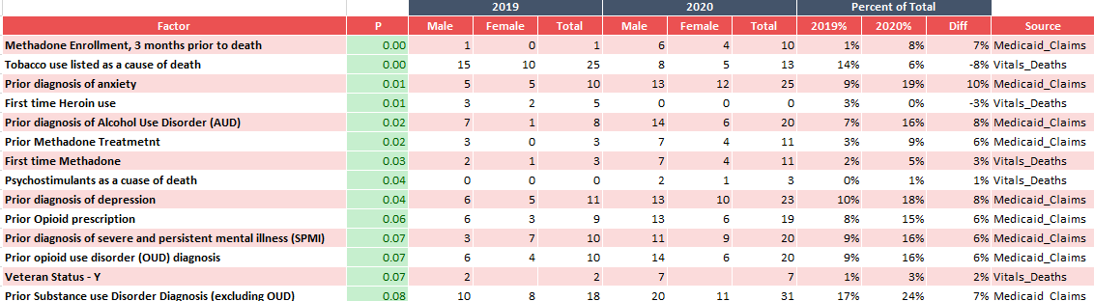
However, prior anxiety diagnoses and several other factors were strongly statistically significant for a key subgroup: those who were in their fifties when they died. In 2020, this group was more likely to have methadone listed as a cause of death; have recently been in treatment; and have had prior diagnoses of anxiety, depression, severe and persistent mental illness (SPMI), alcohol use disorder, and substance use disorder (other than OUD).
Table 2: Select Statistically Significant Factors for Those Who Died Between 50 and 59 Years of Age

This constellation of factors paints a picture of a group of people who may be more significantly predisposed to be triggered by COVID-related isolation or insecurity, but also who may just have a more fragile recovery experience regardless of COVID. They are more likely to struggle with other substance use disorders, and with layered, significant, mental health conditions. As people in their fifties, they may worry about losing a job and not being able to reconnect to or retrain to re-enter.

For both the overall population and those in their 50s, it is worth considering how COVID isolation, economic insecurity, and service disruption may have triggered these underlying diagnoses. Beyond COVID, we see in the data what we heard repeatedly in the focus groups: substance use disorder never occurs alone It is often paired with mental health struggles, and those are often trauma-based. These insights tell us we have opportunities in how we design our substance use treatment programs, at the very least ensuring that mental health services and substance use services can occur at the same time with no payment or administrative penalty. Ideally, however, we serve the whole human being whose personal sense of recovery may only come once their whole self is healed.

Those who Died at HomE
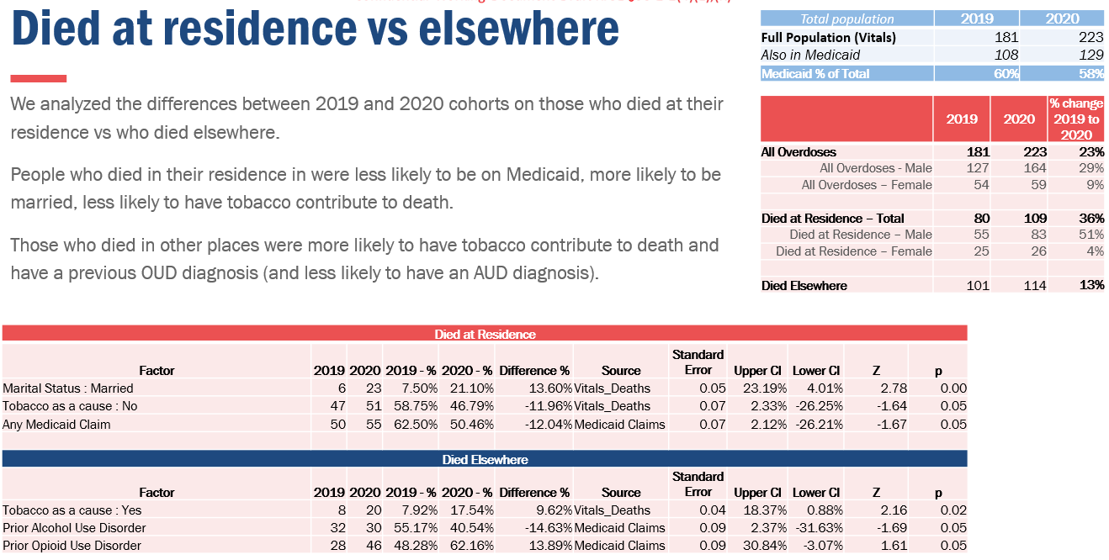
In 2020, nearly half (49%, up from of the 44% in 2019) of fatal overdoses occurred at the person’s home – listed as “died in residence” on the death certificate. For these people, the death occurred before rescue services arrived, or before they could transport the person to a hospital.
Figure 7: Key statistics on those who died at home
This group who died at home in 2020 were more likely to be married (+13.6 percentage points of those who died at home, +17 people) and not have been enrolled in Medicaid at any point between July 2013 and the time of death (-12 percentage points, 5 fewer people). Conversely, those who died elsewhere – so, in a hospital emergency room, in an inpatient setting, during transport, in a location other than the person’s home – were more likely to have a prior opioid use disorder diagnosis (+14 percentage points, +18 people) and less likely to have an alcohol use disorder diagnosis (-15 percentage points, -2 people).
Change,
2019 - 2020
 | 2019 | 2020 | Count | Percent
Men | 55 | 83 | 28 | 51%
Women | 25 | 26 | 1 | 4%
Total | 80 | 109 | 29 | 36%
Men as % of Total | 69% | 76% |  | +7 pp
We also noted that males made up a greater share of those who died at home in 2020, growing from 69% of the total to 76% of the total in 2020. This gender balance reflects the overall overdose rates as well: 73.5% of fatal overdoses in 2020 were men, up from 70.2% in 2019. The growth in male overdose victims, though, appears to be concentrated among those who died at home.

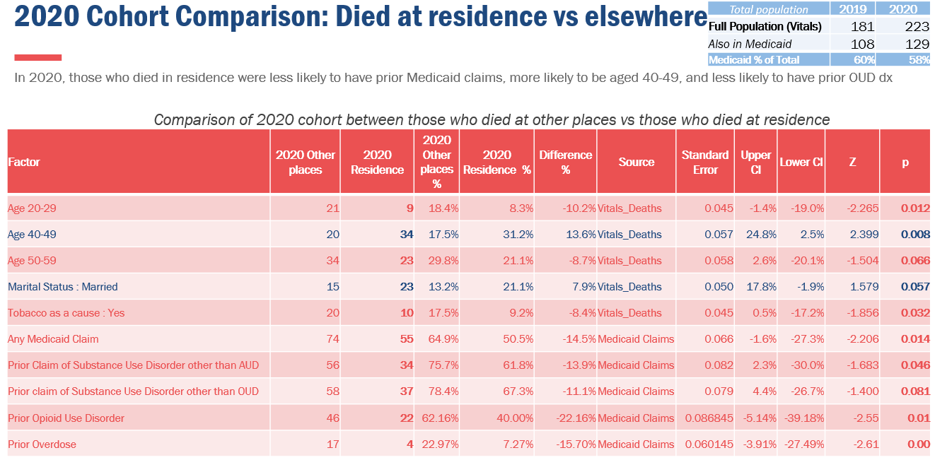
We also reviewed the differences between those who died at home in 2020 and those who died elsewhere in the same cohort. The group who died at home were more likely to be in their forties or fifties and be married at the time of death. Those who died elsewhere were younger, more likely to have been on Medicaid, and to have prior SUD, OUD, or overdose diagnoses.
Table 3: Statistically Significant differences between Those who died at home in 2020 vs. those who died elsewhere

At a high, broad level, we see a picture of those who died at home to have markers of stability – fewer prior substance use related diagnoses, fewer prior overdoses, marriage, middle age, less likely to be eligible for Medicaid – and, as the category implies, having a home. The growth in this group is not massive – it’s 29 more people and five percentage points of the total – but that is in just one year. We know rather than being a one-time aberration, COVID has caused weaknesses in our support system that will take years to repair – and it exposed and worsened existing weaknesses, which we must address.
There are many reasons why a death may occur at home, and the previous factors we’ve highlighted, combined with concurrent trends, may explain some of this pattern in 2020. We detail these findings in the qualitative sections as well:
COVID-Related:
- Because of COVID-related business closures, people were more likely to use alone, or in private residences, and less likely to be using in a public space, such as a public bathroom, where bystanders may have been more likely to call rescue services.
- Beyond required closings, COVID-driven isolation may have also come from fear of public places and mixing with those who may have the virus.
- People may have avoided calling rescue services because of fear of COVID contamination – either through contact with rescue services or in the hospital
Fentanyl: Continued contamination of the drug supply, including of non-opioids, means that people may not have been prepared, especially at home, for the potency of the drugs they ingested
Civil Unrest and Institutional Mistrust: Finally, the killings by police of George Floyd, Breonna Taylor, and too many others this year ignited civil unrest, anger, and open mistrust of law enforcement from years of historical inequities and structural racism. Police officers are generally called to the scene of a drug overdose or drug activity when rescue is called, which may have had a chilling effect on people’s willingness to call for rescue services. Indeed, some of our law enforcement colleagues noted a substantial drop in calls for service in 2020, despite rapidly increasing overdoses.

Other Key Analyses to Inform Quantitative Review
Finally, we investigated a few other environmental trends that may have exacerbated the fatal overdoses in 2020. First, we looked at those who received opioid agonist therapy – buprenorphine, specifically – at Roger Williams Medical Center (RWMC) before it closed in May 2019. We tested the hypothesis that this closure may be associated with more deaths among those who were treated and may not have found a treatment home after the closure.
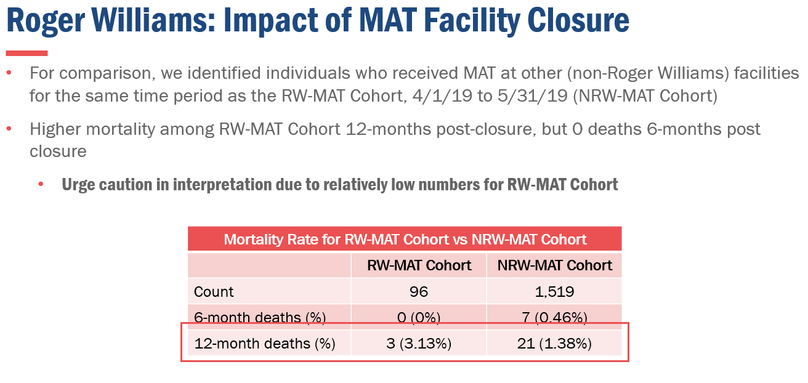
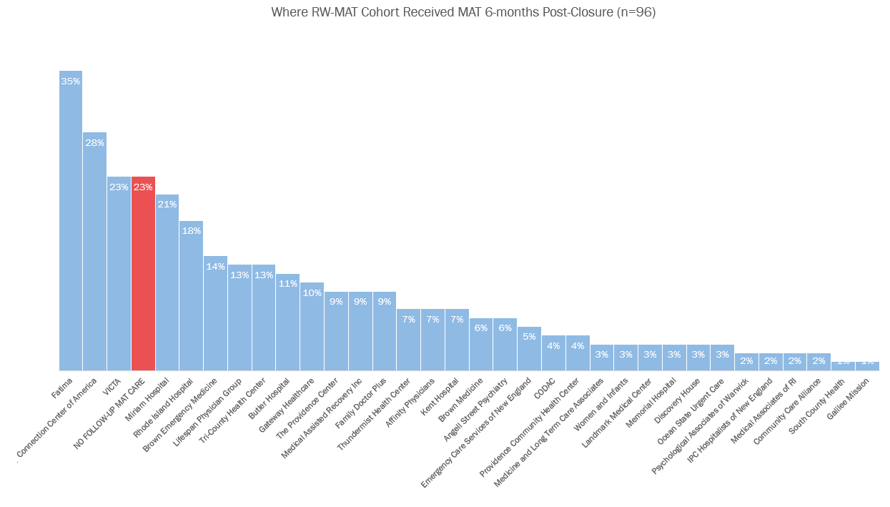
The results allowed us to rule out the closure as a cause of the increase in deaths. Of the 96 people in Medicaid who had a treatment record at RWMC during April or May 2019, none died in the six months following closure and three died in the 12 months following closure. This rate was approximately the same for those who received treatment elsewhere during this period. We also found that 77% of people had records with other locations after the treatment center closed.

Census, Intake, and Release trends in the Department of Corrections

We also reviewed trends in the department of corrections during this period to help us understand environmental factors that may contribute to overdose. The Rhode Island Department of Corrections (RIDOC) plays an important role in the treatment system as one of the largest, most consistent, and most comprehensive locations for medication assisted therapy – including naloxone – in the country, let alone the state. However, we also know that those recently released from incarceration are at very high risk of fatal overdose if the treatment was short or interrupted, or the handoff is not successful.

COVID also brought about already-developing census trends due to partnership with the courts and local police to reduce unnecessary admissions and to accelerate releases of those who were ready to reintegrate. To accommodate the COVID-pressed capacity limits, the courts and local police reduced the number of people who were sent to RIDOC for admission and RIDOC accelerated releases for those who were ready to integrate. The result was a 20-30% sudden drop in the prison census, especially in minimum security, driven more by increased releases than reduced admissions.

The implication is that our non-RIDOC treatment and recovery system had to absorb a large number of people in need of support at a time when the system itself was deeply stretched and trying to adapt to its own new COVID reality. The reduced intakes also mean that fewer people may have been assessed and started on treatment during this period. These trends do not imply that the RIDOC is the ideal place for treatment to occur, nor that arrests and incarceration exist in part to provide a public health function – just that those who are incarcerated receive the medical treatment they need. However, the bottom line stands that, in 2020, the population receiving these services declined sharply and suddenly and entered an already weakened treatment and recovery system.

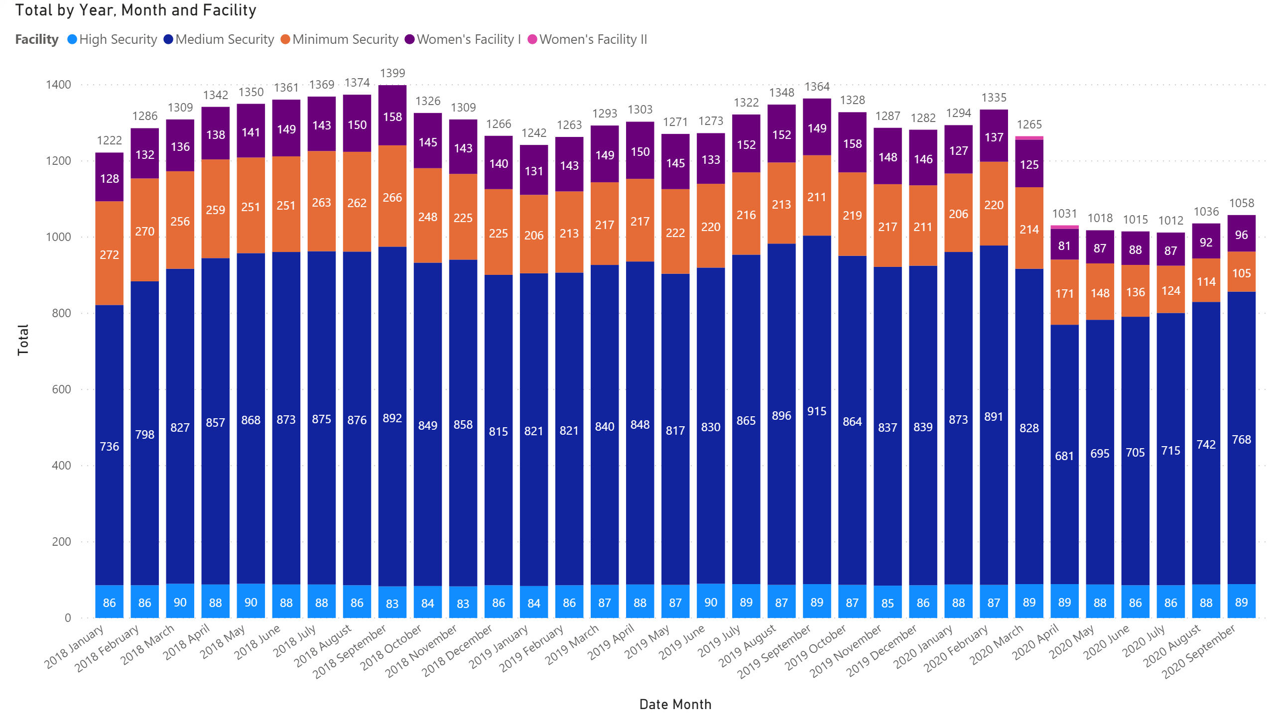

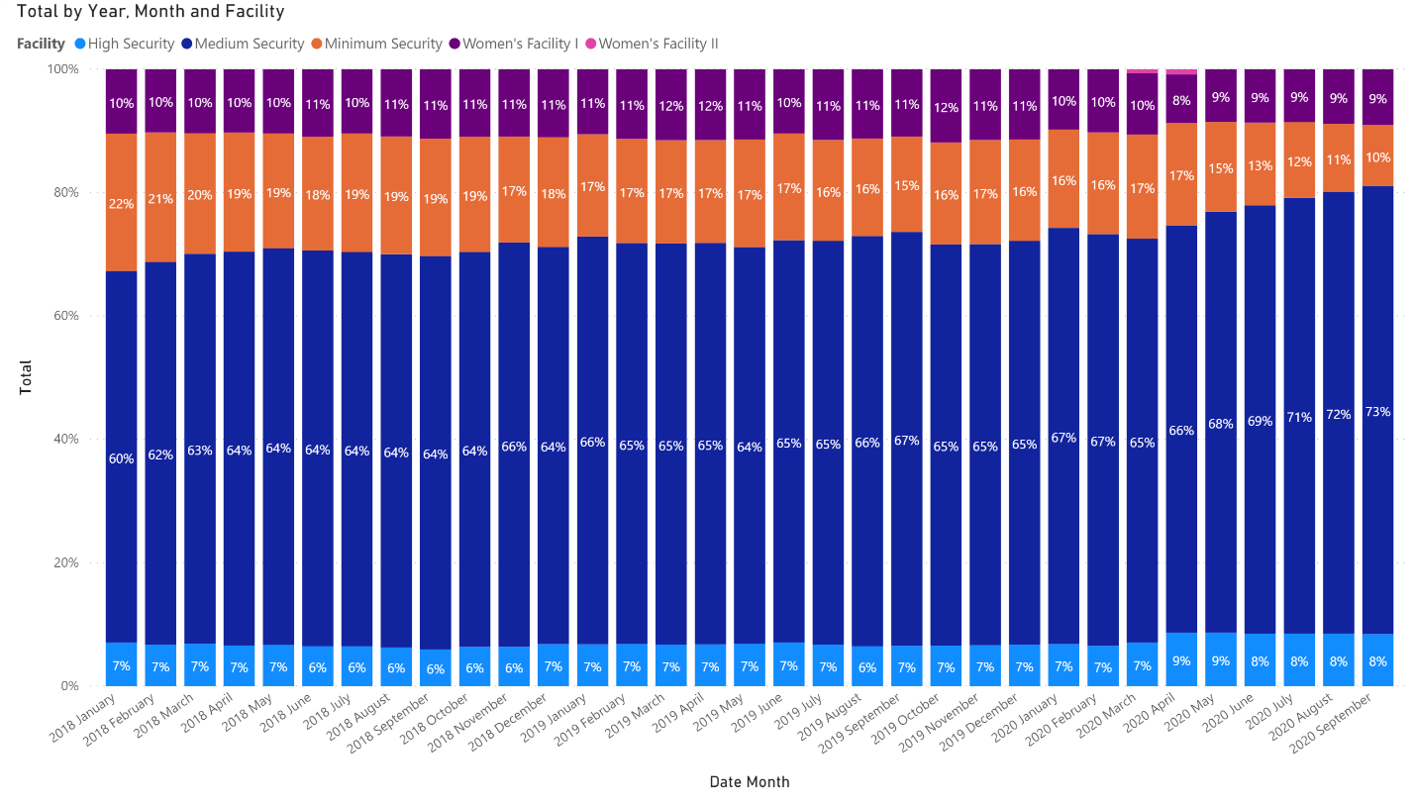
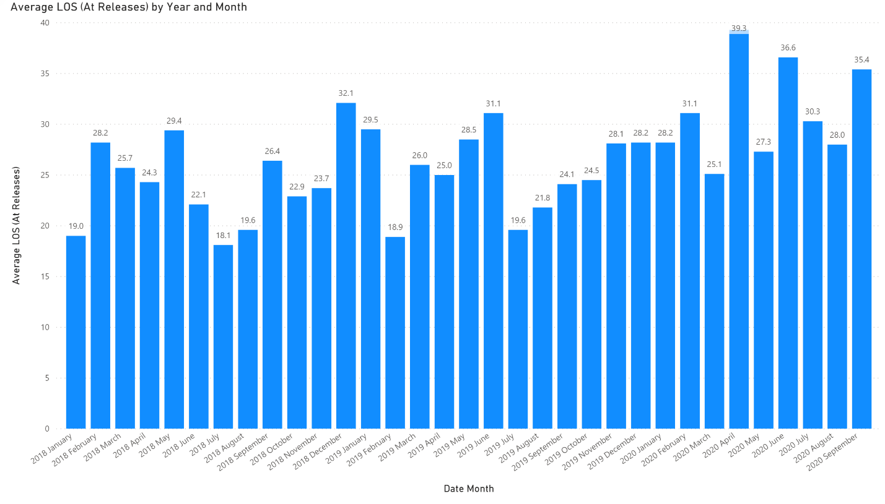

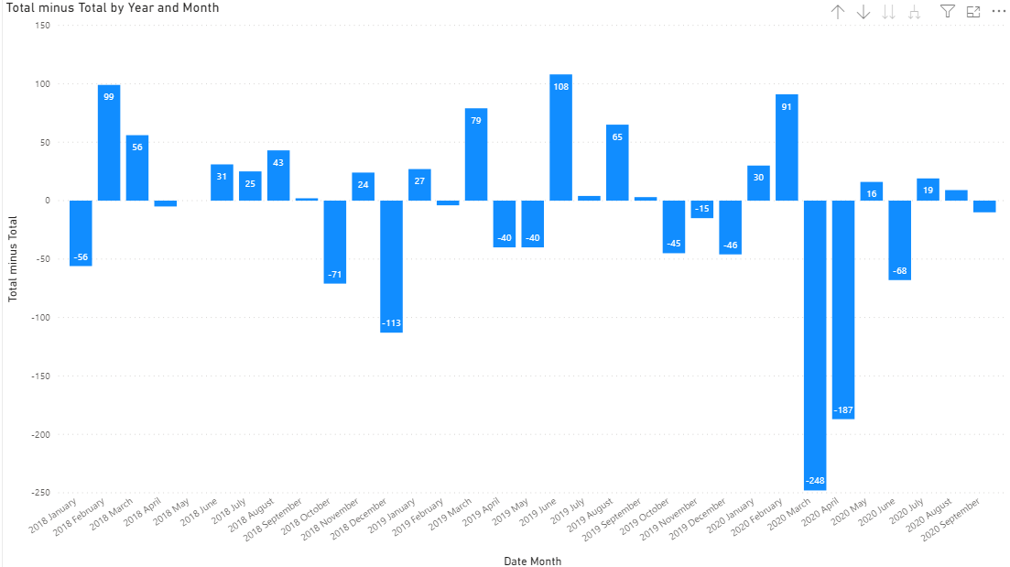
More releases than intakes
More intakes than releases

Wages and income support
One final analysis we undertook was income patterns – both earned wages and additional supports – for those who had a fatal overdose during our study period. We tested whether the 2020 cohort had significantly different wage patterns that might explain their increased overdoses – whether it was more wages that could have fueled drug purchases, or fewer wages and associated economic and mental anxiety that may have driven a return to use.

For context, during this period, the unemployment rate in Rhode Island grew from 3.5% (Nov. 2019) to 12.6% (June 2020) (US Bureau of Labor Statistics, 2021). We would then expect to see lower wages for the 2020 cohort, especially those who died towards the end of the study period (April – June 2020) and a much larger portion of people receiving unemployment or Pandemic Unemployment Assistance (PUA) benefits.

And indeed, we see those trends emerge. Median wages for the 2020 cohort were lower than the
2019 cohort in the first and second quarters (individually) prior to death. We also saw that in the quarter immediately prior to death, the 2020 cohort was more likely (44% vs. 20% of 2019) to have wages below the federal poverty line for a single adult with no dependents. There was less difference over the whole year, implying that to the extent there were differences, it was mainly in the quarter immediately preceding the death, which will naturally have a substantial effect on behavior and outcomes.

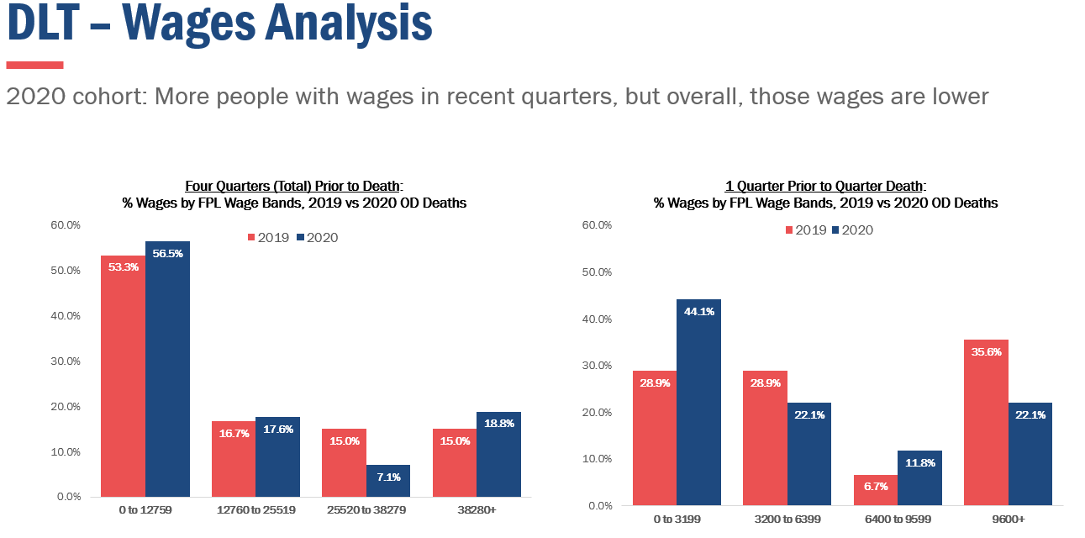
Finally, we did review the claims for income support, such as UI, PUA, and TDI – but found that the number of recipients was too small and the underlying circumstances were two difference between the two years for a reliable analysis.

Qualitative + Quantitative: Combined Study Results

The team has aligned the results of the quantitative study and the 44 interviews and focus groups to lift up three major drivers of the rising numbers of deaths, and an overarching structural issue which has made it difficult to address the situation.

The three major drivers were abundantly clear from the data and the interviews:

- Fentanyl: The inclusion of fentanyl and analogues in more drugs (including non-opioids), with deadly potency. Experts shared with us that:
- Fentanyl is cheap to make, is physically addictive (unlike some stimulants) and may be, within the past 12-24 months, infiltrating the US through new non-opioid distribution channels.
- According to experts, fentanyl is present in much of the drug supply in Rhode Island, and 76% of people who died from overdoses had fentanyl in their toxicology screens. The research team heard and saw that it is difficult to find pure heroin now, if someone wanted to – and fentanyl exists in cocaine, counterfeit pills, and marijuana.
- The team also heard that it is difficult enough to fight a fentanyl overdose when you’re prepared with naloxone – let alone if you don’t think you are using opioids at all and your cocaine is laced with fentanyl.

- COVID-19: COVID-driven social isolation, fear of disease, and economic insecurity. Experts shared with the research team that:
- COVID has increased anxiety and other mental health issues for a majority of people in the world (see this World Health Organization article) – and so to find increased concerns within the population of people who use drugs is no surprise. Experts saw most of the people who use drugs in Rhode Island present with co-occurring mental health challenges pre-COVID.
- The enforced isolation stemming from COVID was difficult for everyone. In the case of people who use drugs, the team heard that isolation could lead to more of a desire to use, even for people in recovery (especially early recovery). It also meant that more people were using drugs alone, which puts people at risk for overdoses without the ability for anyone else to administer naloxone.

- Structural racism: All of the factors the team studied are more acute for communities of color, for whom historical inequities and ongoing structural racism have deprived them of equitable capital (recovery, financial, social), trust in institutions, and access to equitable services.
- One of the most important issues the research team uncovered within this driver is institutional mistrust. This includes mistrust between people who use drugs and law enforcement.
- This institutional mistrust exists alongside the historical effects of racism, which has led to a significant difference in response to people using opioids (focus on treatment since the early 2010s) than to people using stimulants (focus on prison, since the 1980s). The historical effects of racism also include economic barriers, with less generational transfer of wealth, and thus less chance at having adequate recovery capital.

The structural issue which exacerbated these drivers and made them more difficult to deal with is:

- Governance: An insufficient governance and project management structure limits our ability to guide a consistent, focused, strategic response that weaves emerging information into action. A more effective governance structure, with a single point of accountability, and no single points of failure, would allow us to react more quickly to upticks and changes in the data. Experts shared with the research team that:
- There are dozens of state and community programs and efforts that are achieving important gains. However, when they are not aligned or communicated, there is risk of duplication of effort, lack of full impact, and/or an inability to grow the efforts to scale.
- Fractured funding from federal and other grants – each with their own requirements, timelines, and ending dates – makes it difficult to sustain programs that work or truly innovate with new programs in a timely way.
- Challenges in data production about causes of death make it difficult for outreach workers to move quickly to hot spots.

As we reflect on these drivers, it is important to take a look back at the end of 2019 and the beginning of 2020. At that point, leadership of the Governor’s Overdose Task Force was recognizing that numbers of deaths were growing. What the Evidence Update and Strategic Program Review uncovers is that the combination of the significant amount of fentanyl in the drug supply added to the risk posed by the COVID pandemic plus the additional trauma of structural racism can explain the growing number of deaths in 2020, and an insufficient governance structure underlines the state’s difficulty in pivoting quickly enough to prevent them.

Current Activities:

It is important to note that the recommendations of this report are not made in a vacuum. The people and organizations participating in the Governor’s Overdose Task Force are already doing a tremendous amount of work to address rising overdose deaths – and the recommendations are meant to align with the existing work. The list below are examples of the ongoing activities, and not an exhaustive review:

Harm Reduction:

- Through the CARES Act dollars, the state made the following investments in December 2020:
  - 10,000 Chances Project: Purchase and distribution of 10,000 naloxone kits
  - New funding for Peer Outreach Team, who have been working and distributing harm reduction kits, adapting quickly to continue throughout COVID
  - New van for AIDS Care Ocean State for clean needle distribution
  - Reworking naloxone messaging short-term (for December 2020 and the beginning of 2021
- Naloxone access through pharmacies and law enforcement agencies carrying kits

Recovery:

- More Peer Recovery Specialists positions filled – and now being reimbursed by insurance
- Recovery Friendly Workplace program
- More COVID and State Opioid Response dollars to support Recovery Housing

Treatment:
- MAT: No waiting lists, strong methadone infrastructure, and MAT at the Adult Correctional Institutions
- 24 hours buprenorphine induction hotline
- BH Link’s services
- Coordination between DCYF and social workers at birthing hospitals, to support pregnant moms
- Telemedicine started quickly when COVID began, through work of providers, insurers, and the state – and is continuing into 2021 through Executive Order

Governance/Overall Activities:

- Being a small state and having the ability to connect, network, and share resources across the state. Examples include the Overdose Task Force and Community Overdose Engagement (CODE) meetings
- Strong support of the recovery community from state's top administrative and legislative leaders
- Starting to talk about race equity in a serious way, including with the creation of the Overdose Task Force Racial Equity Workgroup
- More community engagement – listening to community voices
- More state interagency coordination and collaboration
- More data collection – and sharing data between the state and community organizations more quickly

Context of the Report Recommendations

The situation that sent the Task Force Co-Chairs to request this Evidence Update and Strategic Program Review from EOHHS was the rising number of deaths. The Co-Chairs specifically asked the research team not to redo the existing Task Force Strategic Plan nor to reconsider the existing four pillars that make up the plan: Prevention, Rescue, Treatment, and Recovery.

Therefore, research team asked questions aimed at determining why more people were dying, starting at the end of 2019 and into 2020 – and each focus group or interview included an overarching question: If the interviewee had a magic wand and could change anything about our response to the addiction and overdose epidemic, what would they do?

As noted above, the interviews uncovered the three specific drivers and the governance structural challenge. The magic wand question, though, led to hours of insightful commentary on all of the pillars and how changes in implementation efforts could address the three drivers of the growing numbers of deaths – as well as ongoing challenges within the rest of the work.

And therefore, as noted above, the report includes a large number of recommendations to address rising deaths and the ability of the Task Force to implement its strategic plan:
- Short-Term: These can be implemented right away, to have an immediate impact on the rising overdose deaths. They include the institution of a more rigorous project management structure for the Task Force, to ensure that the implementation is tracked appropriately.
- Priority Recommendations: The priority recommendations home in on urgent calls for a renewed focus on harm reduction and the promotion of increased treatment availability and recovery resilience.
- Full Recommendations: These include ways to promote more effective prevention activities and improving the state’s overall messaging capacity and output.

The recommendations come either specifically from the research participants or from documented best practices – or in the case of the governance arena, from examples of existing or prior governance structures (i.e., the state COVID response and the State Innovation Model Test Grant). Not every recommendation addresses the specific drivers of the growing numbers of deaths, but taken together, they are an implementation blueprint for the existing strategic plan, by pillar.

In discussing the recommendations, Task Force leadership acknowledged that the state will likely not be able to carry out all of the recommendations – and that prioritizing them and ensuring that we can implement them with fidelity can be even more important than accomplishing every single one. The prioritization and planning process are taking place in the first Quarter of 2021 and will be publicized through PreventOverdoseRI.org.

Suggested Priority Recommendations:
These are the recommendations that rose to the top of the majority of the qualitative conversations as ways to address Rhode Island’s rising overdose deaths.

(A) Fight Fentanyl Overdoses with Expanded Harm Reduction
- Address the challenges of the Good Samaritan Law: Formally evaluate the Good Samaritan Law to determine its implementation, and support proposed changes that arise from that evaluation
- Review the feasibility (including impacts of federal law and potential need for legislative action) of a pilot overdose prevention site that would provide a broad range of drug user health services
- Establish a workplan to ensure every strategy and implementation plan has actions steps to reduce structural racism, and that these actions are measured and reviewed routinely
- Add “Harm Reduction” specifically to the Rescue Pillar title
(B) Address COVID impact: Recovery Resiliency/Capital/Connections
- Prioritize and fund a medication-first treatment approach that reduces barriers to continued engagement with treatment, including residential treatment
- Include and fund trauma-informed mental health services in SUD or alcohol treatment
- Recruit and support peers who reflect the diversity of those they serve
- Elevate focused employment and re-employment efforts (including Real Pathways & Recovery Friendly Workplaces), with work that is more conducive to recovery
- Safely prioritize in-person recovery services wherever possible
(C) Create a Focused, Staffed Governance Structure
- Elevate the community's voice, including appointing community co-chairs to co-lead each workgroup
- Create a full time, dedicated Director of Overdose Prevention + Response, who leads an interagency team with project management capacity, to address the full recommendations

- Create a standing legislative/policy team with membership from each of the Workgroups, advisory to the Task Force
- Overhaul state messaging: fact-based; nationally researched, locally tailored for variety of audiences: people who use drugs, their families and supporters, and people not using drugs
- Align and braid dollars and pursue new funding, to ensure sustainable support for key efforts to prevent overdose death

Short-Term Recommendations
- Secure Project Management and functional lead staff from existing state staff. Carry out an audit of all existing meetings/stakeholder engagements to coordinate current work.
- Continue more effective messaging development for harm reduction, especially focused on men 50-59 years old, using SOR dollars
- Seek dollars for basic needs for people who use drugs, as existing funding cannot purchase many harm reduction items (needles, fentanyl strips, etc.)
- Work with the Department of Labor & Training to create messaging promoting harm reduction, treatment, and recovery support
- Fully implement the 10,000 Chances Program, and get naloxone into public housing
- Designate a facilitator for an ongoing conversation with community and law enforcement leaders to enable harm reduction practices and by building champions for harm reduction in law enforcement.
- Recruit and train more Peer Recovery Specialists who speak languages other than English, who are people of color, and who are recently in recovery
- Ensure more face-to-face recovery services that take into account COVID restrictions
- Strategize on hand-offs from treatment, especially for those with anxiety and prior behavioral diagnoses, and those in the demographics most affected by fatal overdoses
- Implement more effective data sharing between Peer Recovery Specialists and people in treatment, with better sharing of consent
- Maximize access to treatment: Allow health homes to serve the same people without co-payment challenges, stop tox screens before treatment access
- Engaging the judiciary system to promote treatment and recovery

Full Recommendations by Pillar - Finally, the research team culled all of the specific recommendations proposed within the research, by the pillars of the original Task Force Strategic Plan, and they are in Appendix 1 of this report.

Governor’s Overdose Task Force Implementation Planning

The co-chairs of the overdose task force affirmed the overall findings and recommendations of the Evidence Update and Strategic Program review at the December 9th and February 10th meetings. They have tasked the workgroup chairs with implementing the recommendations, starting with select focus areas for 2021 – the areas that are most likely to reduce deaths.

Broadly, we recommend a governance structure that enables this workgroup-led work to continue with coordinated project management and strategic support. Facets of this governance structure will include:

- Continue sharing the results with key leadership and select community partners, including presentations at Work Groups and Community Meetings, as requested.

- Work Group Alignment:
  - Work Group Chairs have begun to meet and will continue to convene on a monthly basis for cross-pillar insights and to implement the evidence update recommendations
  - Workgroup Chairs have taken the recommendations from their pillars and in the process of creating fully prioritized implementation plans in. They will report back on progress monthly to Co-Chairs in the monthly Chairs forum.
  - Each Workgroup will have a community and state co-chair or will in some other way elevate the community voice for public/private partnership.

- Establish project management support, to assist with implementation of short-term recommendations and coordinate across workgroups. EOHHS is in the process of helping to:
  - Set up Project Management software to track actions and tasks
  - Continue to define the roles of each regular overdose-related meeting that occur around the Task Force strategic plan components, to begin to track action steps, outcomes, dependencies, and gaps.
  - Pair this inventory of current projects with a project management plan of all of the recommendations listed in the Strategic Program Review report for tracking purposes in an initial version of a dashboard.
  - Help track the outcomes of the Task Force Workgroup discussions and develop a 2021 Workplan for the state

- Sustainability & Funding Decisions
  - Co-Chairs and other decision-makers continue to make funding decisions in line with the Task Force Strategic Plan and this Evidence Update.
  - The Opioid Stewardship Fund, State Overdose Response (SOR) grant, RIDOH mini-grants, and SAMHSA block grants are currently using the Evidence Update recommendations framework

Acknowledgements

We look forward to hearing your feedback, and encourage even more vibrant participation from community members in this critical work. The research team thanks everyone who contributed ideas, information, and time to this study.

An immense, heartfelt thank you to:

- Our Task Force Co-chairs: Director Kathryn Power and Dr. Nicole Alexander-Scott, plus Assistant Secretary Ana Novais and Dr. Jim McDonald
- The 100+ focus group participants
- Our Evidence update team and advisors, with whom we say: The Beginning is Near

Evidence Update team + advisors
Leadership
Marti Rosenberg, EOHHS Director of Policy, Planning, and Research; Kim Paull, EOHHS Director of Analytics

Research team

Department of Behavioral Healthcare, Developmental Disabilities and Hospitals (BHDDH) - Linda Mahoney and Sarah St. Laurent

Rhode Island Department of Health (RIDOH) - James Rajotte

EOHHS - Ana Novais, Ashley O’Shea, Kerri White, Annice Correia Gabel, Deb Florio, Cathie Cool Rumsey, and Charlotte Kreger

Quantitative Analysis Team

EOHHS: Annice Correia Gabel, Sivakumar Batthala, Rik Ganguly; Lisa Tse; Alyssa Ribeiro; and Steve Raymond

Medicaid: Rebecca Lebeau

BHDDH: Linda Mahoney, Jamie Goulet, Ryan Erickson, and Lisa Gargano

RIDOH: Roseann Giorgianni, Rachel Scagos, Benjamin Hallowell, Dr. Ewa King, Sam Viner-Brown, and Zuheil Figueroa Lugo

Department of Labor and Training (DLT): Amelia Roberts, Donna Murray, and Kathy Catanzaro

Brown University: Dr. Brandon Marshall, Alex Macmadu, Jesse Yedinak, and Max Krieger

Rhode Island Coalition for the Homeless: Caitlin Frumerie and Jenn Barrera

APPENDIX 1

